1. Package **psych**

------------ R code ----------------------------------------------------------------------------------------------------------

# Check if the package psych is already installed

if ("psych" %in% rownames(installed.packages()) == FALSE)

{ install.packages("psych")}



Select a CRAN mirror site – convenient to you –

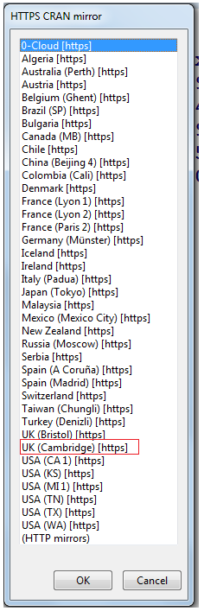

1. Package **lattice** and choose the CRAN mirror site as shown above.

------------ R code ----------------------------------------------------------------------------------------------------------

if("lattice" %in% rownames(installed.packages()) == FALSE)

{ install.packages("lattice")}

1. Package **ggplot2** and choose the CRAN mirror site as shown above.

------------ R code ----------------------------------------------------------------------------------------------------------

if("ggplot2" %in% rownames(installed.packages()) == FALSE)

{ install.packages("ggplot2")}

1. Package **gdata** and choose the CRAN mirror site as shown above.

------------ R code ----------------------------------------------------------------------------------------------------------

if ("gdata" %in% rownames(installed.packages()) == FALSE)

{ install.packages("gdata")}

Please refer to <http://stackoverflow.com/questions/11488174/how-to-select-a-cran-mirror-in-r> for more information.

1. Install R Markdown from R Studio >>>>  **+ > R Markdown**

